Designing REST API Testing Framework

Learning Objectives
- Test GET, POST, PUT, and DELETE with a full CRUD API;
- Learn how to explore the API and find bugs in it;
- Understand common process of designing a REST API testing;

Prerequisite
- Have Node.js installed: download Node.js from https://nodejs.org/en/download/;

Setting up Application
Set up the application for local use with the following steps:
- Download the application from the GitHub repository for this course (https://github.com/arthurguau/ToDoListApp.git).
- To install the application, ensure that the downloaded files are in the folder you want them to be in, and then open Command Prompt and navigate to that folder.
- Once you are in the correct folder, call npm install to install the application. This will install all of the dependencies that you need and get everything ready.
- After the npm install has completed, you can start the application by calling node application_server.js as shown in the following screenshot:
Figure 1 - Server running correctly

Initial testing
To get started with exploring, you will need to first have some familiarity with how this API works:
- Ensure that you have the server running and then create a new collection in Postman called something like ToDoListAPI.
- Add a request to this collection called tasks and set the URL of the request to http://localhost:3000/tasks. Make sure the request method is set to GET.
Send the request and you should get back a list with one task in the list. In the task data, you will see that there is a taskId variable. Let's check on the owner of this task.
- Add a new request and set the endpoint of the request to http://localhost:3000/owners/1 and the method to GET. Send the request.
This gives you the name of the owner, but notice that it does not give you any information about what tasks this owner is assigned. If you add another request that looks at the response of the /comments/1 endpoint, you can see that it includes an entry with the taskId variable of the task it is associated with. This means that you can use the _expand parameter on the comments but not on the owner.
To create a new task entry:
- Set the action to POST and the endpoint to http://localhost:3000/tasks.
- In the Body tab, set the type selection to raw, as shown in the following screenshot:
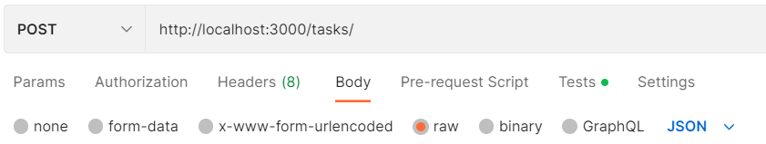
Figure 2 - Setting the raw body type
- Choose JSON from the drop-down menu, as shown in the next screenshot:
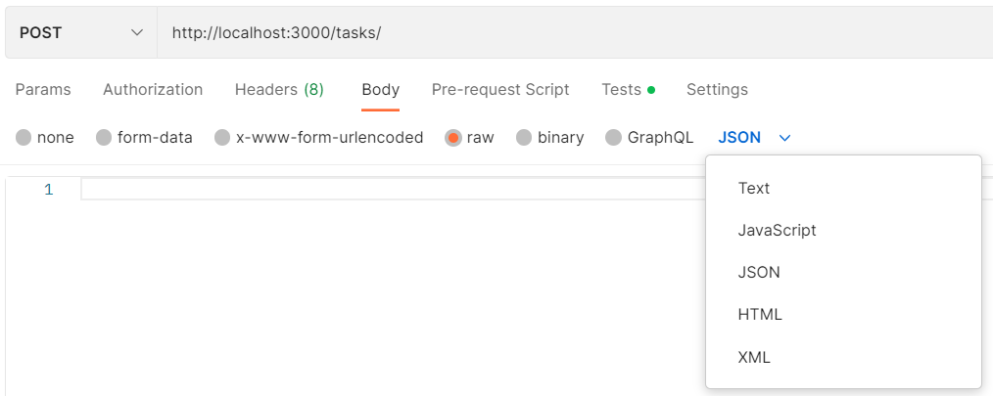
Figure 3 - Set the body type to JSON
You can then fill out the actual body of the request. You don't need to specify the ID since the server will automatically create it with the next available ID, but you can set the title, body, status, and ownerId fields by specifying JSON similar to that shown in the following code snippet:
{
"title": "The second task",
"body": "This is my second task",
“status”: “New”,
"ownerId": 1
}
- Send the request and you should see that a new blog post has been created.
You can also check that it has been created by changing the action to GET and sending the request again to see the full list of tasks in the system.
To modify an existing task:
- Go back to the request that gets the task information and change the endpoint to /tasks/1.
When you are modifying a resource, you need to let the server know exactly which resource you are modifying and so you need to specify the task ID in the endpoint. The task ID (1 in our example) is the resource identifier that tells the server which task we are interested in.
- Set the API action to PUT.
As with creating a new resource, you need to specify the data that you want to modify. You do that in the body of the request.
- Set the Body type to raw and choose JSON from the drop-down menu.
- Specify which fields you want to modify. For example, to modify the body of the task, you could specify JSON as shown in the following snippet:
{
"name": "The first task",
"body": "This is my first task. Look I modified it!",
“status”: “New”,
"ownerId": 1
}
A PUT call will not just update the fields that you request but rather will replace the entire resource with the data you have given it. This service does not support it, but if you are interested in only changing one property (as we are doing here), you can sometimes use the PATCH method instead of PUT.
PUT generally updates a resource by replacing it while PATCH is intended to only modify the specified fields and leave everything else the same.
Deleting data is simple with this API. Just call the endpoint for the resource that you want to remove and specify the action as DELETE.
Resetting the service
As you try things out in this API, you might end up causing corruption that the API can't recover from. You can do that with the following steps:
- Go to Command Prompt that the service is running from.
- Hit Ctrl + C to stop the service.
- Call node reset_db.js to reset the data.
- Restart the service by calling node application_server.js.
This will reset all of the data back to this initial state for you.

Finding bugs in the API
This API is not very robust. It doesn't do much error checking and so it should be pretty easy to break it. Before moving on I want you to do just that. Spend some time exploring how this API works and trying to break it. There are several possible ways to do that, and I would strongly encourage you to spend a few minutes thinking about the kinds of inputs and configurations you could use that might cause problems for this API. See if you can get the server to give you a 500 error!
Note that this is meant to be a challenge, which means that it is OK if you find it a bit tough to do. Stick to it for a while and you might just be surprised at what you can do. It's OK to feel a bit frustrated and lost sometimes as that is often when the most learning is happening! I will share with you one of the ways that you might see an error later on in this chapter, but first, see what you can find on your own.
As a reminder, when you are looking for bugs, don't just try the things that you expect to work. Think about what things you could try that might show you places where the API doesn't work. For example, you could think of things like the following:
- What would happen if I used the _embed and _expand parameters in places where it wouldn't be able to do anything?
- What kinds of inputs to the system might break things?
- Could I create links between different parts of the system that might break stuff?
- Could I remove links between different parts of the system that should be there?
Add your own thoughts to a list like this. What kind of things can you think of that might make this API break? This API is meant to be broken in various ways, so see what you can do to find those broken spots. Since this API is meant to break, let's look at how you can reset it if it does break.

Bugs
There are several bugs that you might have found in this API. I will share the steps to reproduce one of them here so that you can get a better feeling for how to find a bug like this. Finding this bug comes down to combining two ideas. To understand them, let's look at some steps of how you might figure this out.
Let's start with exploring the _expand and _embed query parameters. If you call the /tasks/1 endpoint with ?_embed=comments, you will get back a response that has the comments for that blog post embedded in it. If you instead call it with ?_expand=comments, it will tell you that you have a bad request.
Comments are children of tasks and not their parents, so it makes sense that we are not allowed to expand it as if it is a parent. We sent an incorrect request and the server correctly responded to that by giving you an error message and a 400 response. Everything is good so far, but we should keep this in mind. Just because the server was able to handle the error properly here, doesn't mean it will be able to do so everywhere. What would happen if we tried to do this same expansion, but this time, instead of doing it on an individual endpoint, we did it on the blog posts list?
Try calling /tasks?_expand=comments and you should see a 500 error from the server. It turns out that it doesn't handle the incorrect input correctly in this place. There are other ways to trigger server errors in here as well, but hopefully, this example helps you with thinking about how to search for bugs in an API.
Exploring an API and trying to find bugs interactively is an important testing skill, but often when you are looking at an existing API, you will be interested in adding test automation. It is often important to be able to run a suite of tests against an API every time changes are made, so let's turn our attention to the process of creating automated tests.

General idea about automating API tests
API test automation is often valuable, and in this section, I want to help you to think about how to get started with creating it for an existing API. However, I'm not going to walk you through a step-by-step process of doing this since I want you to practice doing this on your own. You will learn more if you try some things out on your own. I won't just throw you in the deep end though. In this section, I will give you a quick review of some concepts that will help you with creating API test automation. I will then give you a challenge that I want you to try, and I'll also give you some guidance on how you might break down your approach to solving this challenge. If you work through this challenge, you will find that you have learned a lot about how to create good API test automation. So, let's start with a review of some important concepts for API test automation and think about how they could play out in creating tests for this API.

Reviewing API automation ideas
We have already looked at exploring this API and so you should have a pretty good feeling for how it works and what the various pieces of it are. Use that information to help you to put together a well-organized collection of tests. Think about how you are going to organize the tests and how you can set things up to test the various endpoints and available actions for each one.
What kind of things do you want to check for each API call? What kind of inputs might you want to use to check these things? It is a bit more difficult to come up with great test cases when you are testing an application that isn't dealing with real situations but try to imagine that this API is for a real To Do List service. What kinds of things would you want to check for something like this?

Setting up a collection in Postman
Think about how you want to set up the collection in Postman that you can use for your testing. The way you setup collection can have a big impact on how easy it is to run and maintain tests later on. Some considerations when defining the structure of your collection:
- What are the various endpoints for this API?
- How does the testing of the different parameters fit into the way I would set up the tests for this collection?
- How am I going to test the various types of actions that are available?
- In what way do the different pieces of this API relate to each other and how might I want to check those relationships in my tests?
Real-life APIs will often be much more complex than this and being able to break them down and think carefully about how you will structure the automation is a crucial skill to have. This structure will be helpful when you start adding tests to the requests.

Creating the tests
Once you have the structure in place, you can start to flesh it out and create the tests themselves. You will want to fill in the appropriate URLs for each request, being sure to create parameters wherever it makes sense to do so. You will also want to consider whether there are any places where you could use data-driven testing to simplify your tests. As you create the tests, here are a few questions you might want to consider:
- What kind of things do I want to check for each request?
- How can I reduce the number of inputs to the test while still getting good coverage?
- Am I using variables and environments efficiently?
- Will these checks be stable and consistent?
- Will these checks actually fail if something goes wrong?
- What will happen when this test is run multiple times?
Creating tests for each of the requests is a big job, but it is a critical part of any test automation work. The things that we check for inside each test will, to a large extent, determine how useful the tests are. Take a bit of time to work through this challenge. You will find that as you try to balance out the need for coverage with the need for some degree of efficiency, you will learn a lot. Make sure you also take the time to think about how you can share data between tests. Environments and variables are powerful tools in real-life API testing so be sure to use this challenge as an opportunity to test your skills on these things.

Designing API test automation
In this section, I will walk you through the process of designing the collection layout, and then I will show you the various tests that I made and how I set things up to share data between them and make them easy to run and maintain. I will also explain my thought process and why I decided to do things the way I did. This will allow you to see what considerations I was using and help you to think about the kind of trade-offs that go into designing API test automation.

Explore API

Understand OpenAPI file
The open api file is the good start point to understand your testing target.

Understand API structure
Before I started creating any requests in there, though, I decided to diagram out how the API worked and how the various pieces of it related to one another. To do this, I explored how the various endpoints worked and drew out a diagram showing how they are related to each other. The following shows what this diagram looks like:
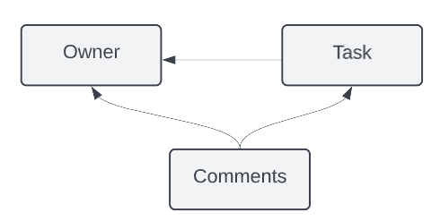
Figure 4 - API layout
This diagram shows what data is stored in each endpoint and shows how they relate to each other. So, for example, in this diagram, you can see that comments are children of Tasks. This means that you can use the _embed query for them. Owner, on the other hand, are parents of Tasks and so if you are looking at Tasks, you would need to use _expand to include them in the response. Of course, inverse relationships exist if you are going in the opposite direction. This is an important consideration that I will keep in mind while designing the test structure.

Map out endpoints and available actions
Now that I have a good grasp of the API structure and relationships, I can look at the actions available on each endpoint. I put together a small table to help me to map that all out, as you can see in the next screenshot:
Endpoint/URL | Actions | Status Code
/tasks | GET, POST
/tasks/{id} | GET, PUT, DELETE
/comments | GET, POST
/comments/{id} | GET, PUT, DELETE
/owners | GET, POST
/owners/{id} | GET, PUT, DELETE
Figure 5 - API actions
An API serves a purpose and although this is a fake API, I can imagine that the purpose it serves is to support a To Do List site. When thinking about that, I want to consider what workflows might be important to consider. For example, when a user posts a comment, maybe we would want the middleware using this API to check whether their owner ID exists, and if not, prompt them to create a account. At the API level, this workflow might look like making the following calls:
- POST /comments: Giving a ownerId that is not yet in the system
- GET /owners/<ownerId>: Where ownerd is the one given in the first step
- POST /owners : Creates a new profile using the next available ownerId variable
- POST /comments: The same comment as before, but now the profile ID exists
- GET /tasks/<taskId>?_embed=comments: To refresh the page with the new comment

Figure out relationship across endpoints
These endpoints have relationships with each other. For example, comments are children of task. You can include children resources in an API response by using the _embed query parameter. An example of that would be to get the list of all tasks with the comments embedded in the response with the following call: GET /tasks?_embed=comments.
You can also look at the relationship from the opposite direction where you are requesting a child resource, but you want the response to also include information of the parents. To do this, you can use the _expand query parameter. This parameter will cause the API to return the requested resource along with information about its parent. For example, if you want to see the first comment in the system along with the information about the task that it belongs to, you can do so with the following call: GET /comments/1?_expand=task.

Setup collection framework

Creating collection
Create a collection named ToDoListApp.

Setup folder structure for smoke testing
Create a folder for each endpoint, which is used to check as smoke tests to let me know that at least the basic functionality of the API was still working.
If I set up each of the endpoints in their own folders and then create tests for this kind of workflow as well, I might end up duplicating some things that I'm checking.
Definition
Smoke tests are a set of tests that can run quickly and give you an early indicator of any potential problems. Much like the saying "where there is smoke, there is fire," smoke tests let you make sure that everything is reasonably stable before you go on with more complex testing. This is a good automation strategy to take so that is how I've decided to implement these tests
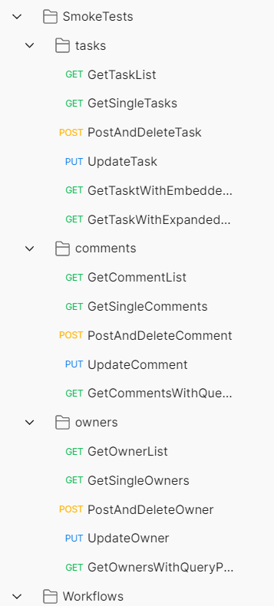
Figure 6 - Test folder structure
Let's zoom in and take note of a couple of things in this screenshot. You can see that I chose to combine the POST and DELETE tests:

Figure 7 - Post and delete combined
This is because I decided that I wanted to try to make it so that:
- Tests leave the system in the same state it was in when the test started.
- This makes it easier to manage the tests since you don't need to worry about what order tests run in.
- It makes debugging easier since you don't need to do much to get the system into the same state that it was in when the test failed.
- To maintain the system state when creating new items, I would have to delete them afterward. Since I need to do this anyway, I just combined them both into one test. I should note, though, that a Postman request can only use one action type, and so to do this, I will need to use some background calls. I will show you how I did that in the Creating the tests section.
I also have not included separate requests for each of the query parameters. Instead, I plan to use data-driven testing to exercise those different options.
I included a couple of examples of the kinds of workflows you might check with something like this. In real-life applications, these would be built out based on conversations with project managers and others in the business along with the developers and testers.

Setup folder structure for work flow
To do

Prepare test data
to do

Creating the tests

Fill in the endpoints for each of the requests
I'm going to need to go through each one and add the URL, but I want to be forward-thinking as well. I'm working on a local build here. What if, in the future, I was to need to test this on a production server somewhere or even just on a different port number? I don't want to have to go through and update every single URL in this test suite. This is where environments are helpful.

Updating the environment
To make future maintenance reasonable, I will make a variable to store the base URL for this collection, as shown in the following screenshot:
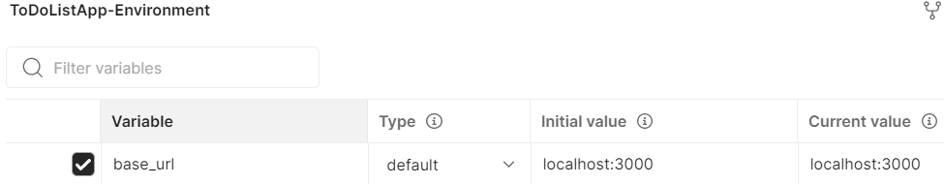
Figure 8 - Creating an environment
IMPORTANT NOTE
As shown in the previous screenshot, environment variables have an initial value and a current value. With a newly created environment variable, those values will both be the same, but if you modify the value later, Postman will set that in the current value while keeping the initial value there for your reference.
Once I have added the environment and made sure that it is the active environment, I can enter the request URL for each of the requests. For example, the URL for the GetTaskList request would look like this:
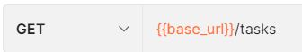
Figure 9 - Request URL
Using a similar pattern, I can quickly add the URL to each of the requests. I also add a variable to the environment for the id of each object type, as shown in the following screenshot:
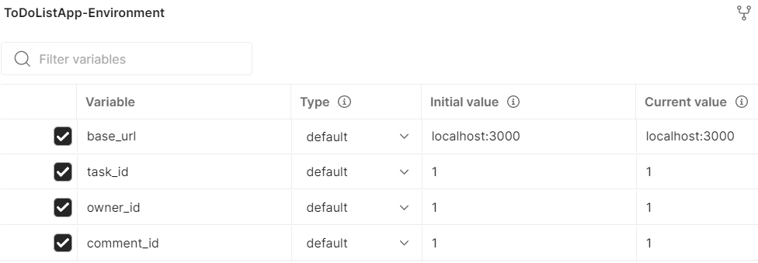
Figure 10 - Object IDs in the environment
This will allow me to use the same request to potentially call more than one of each object. While going through and adding the URLs, I also updated the call methods so that they are using the correct one for each request. Now that this is all filled out, I'm ready to start adding tests to these requests.

Adding tests to the first request
I know that I will most likely want to share some of the tests and scripts that I make across multiple tests. However, a common mistake that automation engineers (and developers in general) make is to over-generalize. They can often spend too much time making a general solution that will work in a wide variety of contexts. This is great, except that it can take a lot of time to make a generalizable solution like this, which can lead to wasted time and effort. To avoid that, I will first add a test to one of my requests and then as I start adding more tests after that, hopefully, I will be able to see which things make sense to generalize and share between tests.
The first place where I will add tests is to the GetTaskList request. At this point, there is only one blog post in the list. I could just check that the entire response body does not change. This is an acceptable thing to check if you are pretty sure that the data will be stable. However, if you expect that it might change, you will want to be more careful with checking something this specific. In this case, since this is a list of requests, I fully expect that it will change over time, so I don't want to just blindly check it.
Instead, I set up a test that ensures that the first blog post in the list doesn't change. This check is based on a few assumptions about the system, but we must make assumptions at some point, so I will go ahead with it. I want to create a couple of tests that will all use the response data, so I will create a variable for that and one that stores the first blog post data that I do not expect to change. These variable definitions look like this:
var jsonData = pm.response.json();
var firstTask = {
"id": 1,
"title": "The first task",
"body": "This is my first task",
"status": "New",
"ownerId": 1
}

I can then create a test that will check that the first task data stays consistent:
pm.test("Check first task Data", function () {
//assume that the first task won't change
pm.expect(jsonData[0]).to.eql(firstTask);
});

Now, this is a good start, but if I am checking the list of tasks, I want to do more than just look at the first item in the list. I also want to check that any other items in the list are correct. I will try to set up my tests so that they don't change the system, but I like to be as careful as possible when creating tests. I don't like having to go and update tests multiple times just because of some small change elsewhere in the system. To create a robust check, I will create a test that checks that all of the tasks in the list have the correct fields in them. I can do that with a test like this:
pm.test("Check that each task has required fields", function () {
var x;
for(x in jsonData){
var taskKeys = Object.keys(jsonData[x]);
pm.expect(taskKeys).to.have.members(['id','title','body','status','ownerId']);
}
});
So, now that I have a couple of tests in place for this first request, let's look at some of the other requests and see whether there is anything we can do to share data between the tests.

Adding tests to the second request
The second request I will add a test to is the GetSingleTasks request. This request will get the information about a given task, but don't forget that I've parameterized the task ID for this, so I don't know exactly what task I'm going to get. I can't use the test that checks the first task, but I should be able to do a similar test to the one where I check that each task has the required fields. In fact, I should be able to directly use that same test in both requests.
Instead of having the same test exist in two different requests, I will move it out of the GetTaskList request and into the tasks folder so that both requests can use it. This can be done with the following steps:
- Highlight the text for that test in the Tests panel of the GetTaskList request and cut it, as shown in the following screenshot:
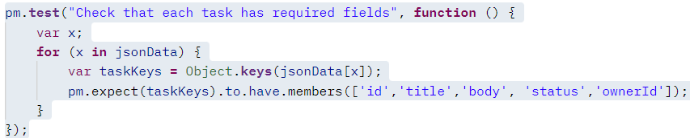
Figure 11 - Cut the test out of the first request
- Click on the Edit option on the menu beside the tasks folder, as shown in the following screenshot:
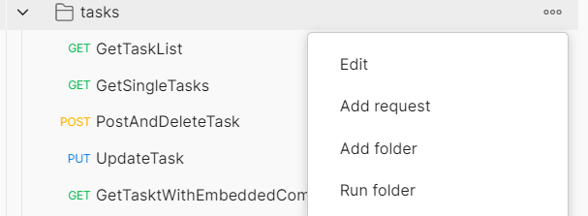
Figure 12 - Editing a folder
- Go to the Tests panel for the folder and paste in the copied test.
- Click on the Save icon at the top-right of the panel to save this test into the folder.
The test is now saved in the folder instead of the request, but if you go to the original GetTaskList request and run it, you will see that the test fails with a ReferenceError since the jsonData variable is not defined. To fix this, I will need to copy the line where I defined that variable from the test into the folder. At this point, the code in the folder looks like this:
var jsonData = pm.response.json();
pm.test("Check that each task has required fields", function () {
var x;
for(x in jsonData){
var taskKeys = Object.keys(jsonData[x]);
pm.expect(taskKeys).to.have.members(['id','title','body','status','ownerId']);
}
});
This test will now run against all of the requests in the tasks folder. For example, if you go to the GetSingleTasks request and run it, you will see that the test is run too. In fact, if you go and do this, you will see that the test fails with an assertion.
At first glance, this seems odd until you remember that the test is looping over all of the tasks in the list and checking each of them. However, when we call the endpoint for an individual task, we don't get a list. We just get back that task. Does this mean that it won't work after all to share the code? Well, not so fast. We should still be able to share some of it. We know that for any given task, the code inside the loop should be valid. I just need to factor that out into its own method and we should be able to use it.
Unfortunately, that is a bit tricky to do with Postman. You can just write a function in a folder and then call it in all tests in that folder. There are some ways to work around this though. I used the following steps to create a function that I could then call in the tests:
- Go to the Test tab of the tasks folder and create a function called check_task_keys.
- Copy the part of the code that checks the task keys into that function.
- Modify the code so that it checks the object that gets passed into the function. The code looks like this:
function check_task_keys (taskData){
var taskKeys = Object.keys(taskData);
pm.expect(taskKeys).to.have.members(['id','title','body','status','ownerId']);
}
- Call the function from inside the for loop. The for loop now looks like this:
for (x in jsonData) {
check_task_keys(jsonData[x]);
}
- Save the folder, and go to the GetTaskList request and run it to make sure that everything still works.
So far, this seems great, but I need to be able to access this function from a request and not just from the folder.
- Edit the folder again and save the function inside of an object. The code for doing this looks like this:
utils = {check_task_keys: function (taskData){
var taskKeys = Object.keys(taskData);
pm.expect(taskKeys).to.have.members(['id','title', 'body','status','ownerId']);
}
}
What this code is doing is creating an object called utils. This object maps the name of the function to the definition of the function, which means that I can call this function by calling that key from the function. In other words, calling utils.check_task_keys(<input object>) will call the function. However, the utils object that I am creating here still needs to be made available for the requests in this folder.
Objects defined in the Tests tab of the folder will not be available until too late in the process, but by moving this to the Pre-request Scripts, I can make it available for all of the tests in the folder.
Once the utils object has been moved to the pre-request scripts, I can copy the Check that each task has required fields test back into the Tests tab of the GetTaskList request and change it so that it is using the utils.check_task_keys() call to check the results. The test should now look like this:
pm.test("Check that each task has required fields", function () {
var x;
for (x in jsonData) {
utils.check_task_keys(jsonData[x])
}
});
That was a lot of complexity to just make it possible to share a couple of code lines between tests. Given how small this API is, it probably wouldn't make sense to do this normally, but I think that being able to share code like this is important if you want to make good test automation and so I wanted to spend a bit of time explaining how to do this.
Now that we have this shareable code, I can use it when adding tests to the other requests in this folder. The test that I add to the GetSingleTasks request looks like this:
var jsonData = pm.response.json();
pm.test("Check that the task has required fields", function () {
utils.check_task_keys(jsonData);
});
This test also uses the shared function from the util object. A nice thing about this is that if the expected keys in the tasks responses were to ever change in the future, we would only need to update them in one place. There are more requests to add tests to though, so let's look at the next request.

Adding tests to the POST request
The next request I want to add tests to is the PostAndDeleteTask request. Before I can add tests though, I need to fill the body of the request that will be sent during the POST call. On the Body tab of the request, I will set the type to raw and then select JSON from the drop-down menu and add the following body:
{
"title": "New Task Title",
"body": "This is a task that I created with the API",
“status”: “New”,
"ownerId": 1
}
I will then add the same test code to this that I was using in the previous requests.
When I set up the structure for this collection, I wanted this test to POST and then DELETE the newly created task so that it wouldn't change the state of the system. Postman allows you to send API calls directly from a script, so you can do that in the Tests tab using the following code:
var task_id = jsonData.id;
var base_url = pm.environment.get("base_url")
pm.sendRequest({url:`${base_url}/tasks/${task_id}`,method: 'DELETE'}, function (err, response) {
pm.test("Delete Response is OK", function () {
pm.expect(response.status).to.eql('OK');
});
pm.test("Delete Response body is empty", function () {
pm.expect(response.json()).to.eql({});
});
});
The pm.sendRequest function allows you to send API calls. You need to specify the endpoint you are calling, the request method that you want to use, and a callback function. You can see that I have defined variables for base_url and task_id. I wanted to ensure that the base URL would automatically update if I ever change it for the collection, so I made sure to use the variable from the environment. I also needed to get the id of the task that was just created and use that in assembling the URL. Obviously, I need to set the method to DELETE and then in the callback I've defined the tests that I want to run.
I have defined the tests right inside the callback to the sendRequest function. The first test checks that the DELETE response returns a response status of OK. The second test checks that the body of the response is empty since I do not expect a delete call to return anything.
This gives us tests for the POST and DELETE call, but we aren't done yet. Now, let's look at the UpdateTask request and see how to test a PUT call.

Adding tests to the PUT request
To test the UpdateTask request, I first need to put something in the body of the request so that it will actually update correctly. Once again, I can do so using the raw and JSON options. I decide to set the body to this value:
{
"title": "modified task Title",
"body": "This is a task that I modified ",
“status”: “New”,
"ownerId": 1
}
As I am doing this, I realize something. When I mouse over the task_id variable in the URL, I can see that I have set it to 1. However, if you remember, I have a test in the GetTaskList request that assumes that the first request will not change. If I change that blog post with the PUT request, the next time I run the request getting the list of tasks, it will fail. I have a couple of options available to me:
- Remove that test from the POST request—the test probably isn't strictly necessary there, so this is an option.
- Create a new task before doing the PUT call—if I did this, I would want to also delete it afterward.
- Get rid of this request and include the PUT call in the PostAndDeleteTask request— this is probably a better choice than turning the PUT request into a POST, PUT, or DELETE request, but it would make that test hard to debug if something went wrong.
- Make sure I set the request back to its initial state after modifying it—I think this is probably the best choice.
I wanted to share this list with you so that you can get a bit of an idea of what kind of thought process goes into designing good test automation. You need to consider things like making one test too big to easily debug and what assumptions your tests might be making.
I think this thought process also highlights why I wanted to make tests that leave the system in the same state it was in when the test started. In this case, I remembered that I had this assumption in one of my other tests, but if multiple people were working on the automation or if it had been a long time since I created that test, I might have accidentally caused another test to fail due to my actions in this test.
So, how do I go about creating this test so that it will not change the system? I used the following steps to set up this test:
- On the Pre-request script tab, I create a request that will GET the data for the blog post and store that response in a variable. The code looks like this:
//get original value
var base_url = pm.environment.get("base_url");
var post_id = pm.environment.get("blogpost_id");
pm.sendRequest({url:`${base_url}/tasks/${post_id}`,method: 'GET'}, function (err, response) {
pm.environment.set("original_get_response", response.json());
});
- Moving over to the Tests tab, I create the same test as the one on the other requests where I am checking that the task has the required fields.
- I can then use the original_get_response variable that I made in the Pre-request scripts to reset the task back to its original state. I will once again use the sendRequest function. Since this time I need to send body data, I need to specify a few more things, as you can see in the following code:
//reset the tasks back to its original state
var base_url = pm.environment.get("base_url");
var task_id = pm.environment.get("task_id");
var original_response = pm.environment.get("original_get_response")
pm.sendRequest({url:`${base_url}tasks/${task_id}`,
method: 'PUT',
header:{'Content-Type': 'application/json'},
body:{mode: 'raw', raw: original_response}},
function (err, response) {
console.log(response.json());
});
You can see that I had to specify the Content-Type header and specify that the mode of the body data I was sending was raw. This finishes up this test. So far, I have created a good suite of tests for the requests that I have. These tests should check the things I care about and not fail unnecessarily. They give reasonable coverage of the endpoints, but I still need to think about how to test the query parameters.

Adding tests for query parameters
None of the tests so far are checking what happens when I use the _embed and _expand query parameters. When I initially designed the test layout, I had thought that I could test these using data-driven testing on the existing endpoints. However, after trying a few things, I have discovered that it would be very difficult to do this due to the way the values of the query parameters are named. I have decided that instead, I will need to add new requests to check each of the query parameters.
This is a very common thing in designing test automation. Much like other development work, you can't plan everything accurately upfront. You will almost always need to have some iteration on what you do.
Based on the diagram that I made for the way the different pieces of the API interact, I've decided to add two more requests to the tasks folder, as shown in the following screenshot:
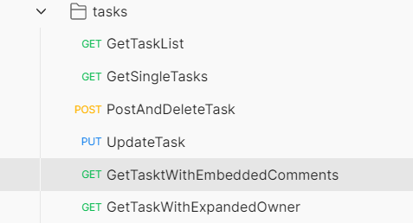
Figure 13 - New requests
I also decided to make the tests for these requests simple. I will just assume that the first task, comment, and owner will not change and then hardcode in the expected values for each of those in the tests. For example, the GetTaskWithEmbeddedComments request looks like this:

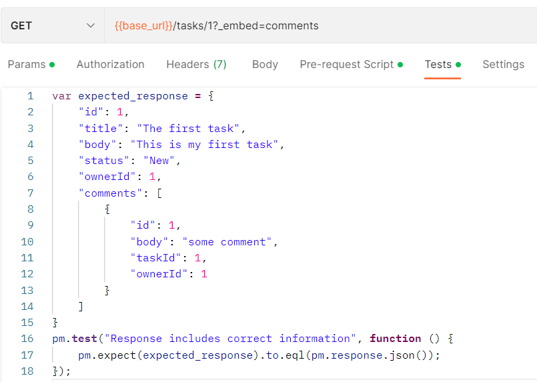
Figure 14 - Embedded comments request tests
GetTaskWithExpandedOwner takes a similar approach to testing this. Now that I have this in place, I can run all of the tests in that folder. I would then need to work through similar steps to set up tests in the comments and owner folders, but at this point, you should have a pretty good idea of how to go about that, so I won't walk through it in detail.

Document collection
Todo

Running requests in the collection runner
Click run collection shown as below:
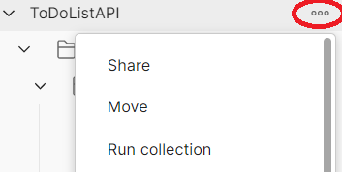
Figure 15 – click collection button

Fill iteration number and delay time if you want to, shown as below:
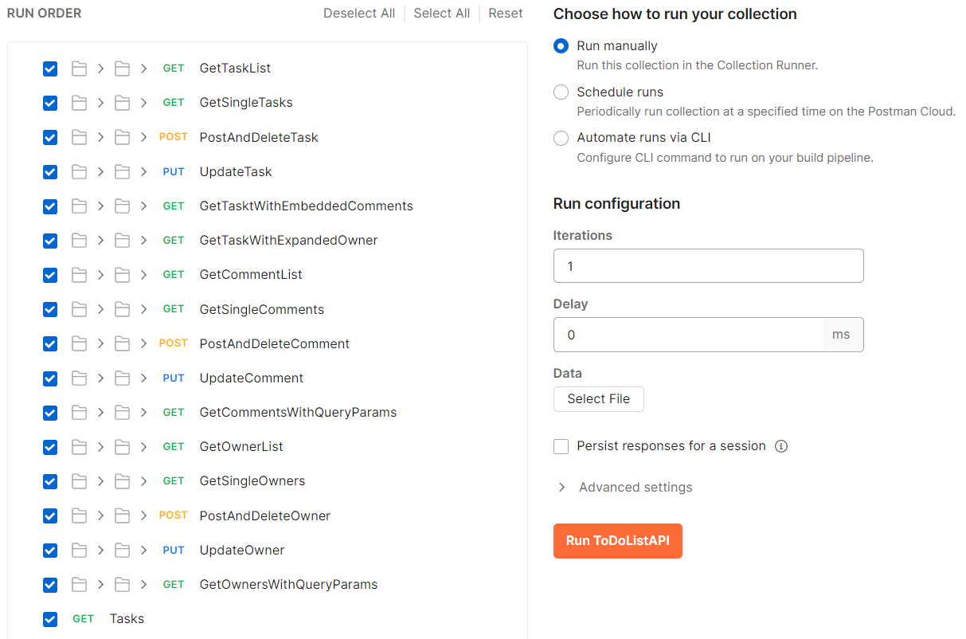
Figure 16 – Run collection

Running requests in Newman
- Install Newman (please refer to API Installation document)
- Install newman-reporter-html: npm install -g newman-reporter-html
Run command in Windows command line:
newman run .\ToDoListAPI.postman_collection.json \
-e .\ToDoList.postman_environment.json \
-n 1 \
-r htmlextra \
--reporter-html-export report.html
Note: the generate html report in newman folder of current directory.

Share your work
You can create a GitHub account. and create public repositories. Once you finish your test cases you can push to your GitHub account. For the detailed steps please refer to API Tools Installation Guide.

Integrate with CI pipeline
To do

